 | Facilitation guide

Dogs and the law
FOCUS: Dogs and the law TYPE: Visual, auditory & kinaesthetic
NUMBER OF PARTICIPANTS: It is recommended you run this activity with just one person.

HOW LONG IT WILL TAKE: To complete the full range of activities in this section will take 1.5-2 hours, but the activities can be done over several sessions.

WHAT YOU WILL NEED:

Activity sheets Facilitators notes
My behaviour towards dogs My behaviour towards dogs – recording sheet
What could happen to me if I break the law? What could happen to me if I break the law?
Action plan for me and my dogs Animals’ basic needs - dogs
Future action plan if I get a dog The Animal Welfare Act 2006

Equipment Factsheets
Pen or pencil The five freedoms
Scissors
Red, green and orange spot stickers
Information about the Dangerous Dogs act 1991 and banned types (see Useful websites section)
Aims and objectives
In this activity, young people will look at a variety of statements that relate to how they care for or treat their dog, or how they would care for or treat their dog if they had one. The facilitator of this activity has a choice of statements to allow them to make this activity relevant to the young person.

The young person sorts these statements into categories. They then investigate whether or not these behaviours are acceptable or against the law and what types of penalties they could face if they break the law. They then create an action plan that addresses any current behaviours that are against the law to ensure responsible dog ownership.

In the extension activities the young person also gets the opportunity to investigate some of the consequences for people who have a dangerous dog and allow him/her to get out of control, if this is appropriate for them. They can also increase their knowledge of the Dangerous Dogs Act 1991, especially relating to types of dogs that are banned under the Act.

Young people will:
- think about their own behaviour towards dogs
- develop an understanding of laws relating to dogs and dog ownership in the UK, especially the consequences of breaking the law, including penalties
- explore whether their own behaviour reflects current UK law regarding dog ownership
- create an action plan where they identify behaviours that need to be changed in order to comply with the law.
Some young people will:
- explore what types of dogs are banned under the Dangerous Dogs Act 1991.

Preparation for the facilitator
- In advance of this activity, it is suggested that you choose the most appropriate statements to use with the young person from the activity sheet My behaviour towards dogs.

- The statements are about different issues related to status dog ownership, including:
  - dog welfare and welfare concerns
  - illegal activities, e.g. dog fighting and dangerous dog ownership
  - risks to other people and animals.
- Make sure that you include some statements related to all of these, but you can also choose to concentrate on some key issues that are relevant to the young person.
- Cut out the chosen statements from the activity sheet as well as the category headings at the bottom. Put them into an envelope ready for use.

What to do

My behaviour towards dogs

- Prepare the statements from the activity sheet My behaviour towards dogs as described in the Useful information section.
- Ask the young person to lay out the category headings (Always, Sometimes, Never) on a table, leaving plenty of space to start grouping the statements.

- Explain that you are interested to hear about their behaviour towards dogs.

  - Say that you are interested to see how they treat their dog or what they think is an acceptable way of treating a dog.
  - Make sure that this is done in a way that is non-confrontational and tell them there is no right or wrong answer.
- Ask the young person to take each statement in turn and put it into the correct category.
- While they are sorting the statements, use the Facilitators’ notes My behaviour towards dogs – recording sheet to record their behaviours by ticking the correct column for each statement.
- They should now have three categories of statements. It is important that these statements stay where they are for the moment. (If you do not have time to run all of these activities in one session, you will need to store these sorted statements somewhere safe, to refer to them later in the activity. You could use three envelopes.)

Dogs and the law
- Explain to the young person that there are certain laws that apply to dogs and their owners and you would like to start a discussion about dogs and the law. Explain that from their sorted statements, you can see evidence of:
  - responsible dog ownership – really good behaviour and attitudes towards dogs
  - activities where they are breaking the law –obviously, if they want to ensure that they keep their dog (and not have it taken off them) and avoid a penalty (e.g. a £20,000 fine and/or six months in prison) or a ban from keeping animals, these behaviours and attitudes need to change
  - activities where they are at risk of breaking the law.
- Explain that it’s important that these attitudes and behaviours are addressed to avoid problems for themselves (and their dog).
- Use the Facilitators’ notes My behaviour towards dogs – recording sheet to begin a discussion about their statements. There is a colour allocated to each answer:
  - Green - this attitude or behaviour is brilliant! This is an example of responsible dog ownership
  - Amber – you should find out more about this behaviour. Under some circumstances this might be acceptable, but in many cases this might actually be against the law
  - Red – this attitude or behaviour should cause you great concern. It is highly likely that the young person is breaking the law or is at risk of doing so.
- Tell the young person that you are going to look at each attitude/behaviour in turn and give it a colour green, amber or red. You can give them coloured stickers or pens/pencils to colour-code their statements.
- Make sure that you give the young person praise for the statements that are green. Explore these further by asking why they do these things. You can refer back to these actions later in the activity, or use them as models for more difficult discussions.
- Ask questions to find out more about their amber statements. For example, ‘When would this be ok?’, ‘When do you do this?’ ‘Under what circumstances is this ok?’
- Explain that some of these actions are unacceptable in some circumstances as they are against the law. The recording sheet gives details about the laws relating to the statements.
- For red, ask them questions such as ‘If that was allowed to happen, what might happen to people/the dog?’, ‘Is that acceptable?’, ‘Do you think that this is against the law?’, ‘Why do you think that?’. Explain that, in many circumstances, this is unacceptable and could even be against the law. The recording sheet gives details about the laws relating to the statements.
- It may be helpful to refer to the information about the factsheet The five freedoms and Facilitators’ notes Animals’ basic needs (dogs). You could use these to discuss what dogs need and what the consequences might be if the dog does not have all of its welfare needs provided for.
N.B. – The laws relating to animal welfare and dogs can be very complex. We have tried to simplify the behaviours and laws to make this activity manageable, but please remember that each case and the individual circumstances are different, so there might be exceptions in some circumstances.
- If the young person has an illegal breed of dog, or thinks it is acceptable to own one, it is suggested that you complete the activity Consequences of irresponsible dog ownership: Case Study which includes a real-life case study of a pit bull attack in which a five year-old girl died.
What are the consequences?
- Explain to the young person that there are obvious legal consequences for breaking the law. However, there might be other consequences that they are unaware of. This is because of a combination of some of their activities and behaviours.
- For example, if they allow their dog off the lead near young children AND they encourage him/her to be aggressive, then one day he/she might attack someone by accident. This could be someone they care about. It could also happen if the dog hasn’t been encouraged to be aggressive. For example, he/she may not have been properly socialised with children at a young age and could find their behaviour threatening. It is important to mention here that a dog should never be left unsupervised with a child, even if the owner thinks it will be fine. Tell the young person that the majority of fatal dog attacks on children happen in the family home. (More information can be found in the Consequences of irresponsible dog ownership section Case study andFocus on people.)
- If they don’t get their dog microchipped, ensure that he/she wears a collar and a tag or keep him/her on a lead in a public place, the young person’s dog might run away and be hit by a car, or be collected by a dog warden. If the owner can’t be contacted or found within a set amount of time, then the dog could be put to sleep.

These consequences are explored further in the activities within the Consequences of irresponsible dog ownership section.

Legal consequences
- Ask the young person to think about what the legal consequences might be if they were not a responsible dog owner. Ask them to complete the activity sheet What could happen to me if I break the law? You do not necessarily need to use all of the statements to discuss. You could highlight the ones most relevant to the young person and concentrate on those.
- Using the facilitators’ notes My behaviour towards dogs – recording sheet and facilitators’ notes - What could happen to me if I break the law?, discuss what they have written.
- Reinforce the fact that they need to look after their dog properly to keep him/her safe, happy and well and to protect others.
- Ask the young person to imagine that they have chosen to get a dog, or are thinking about getting one. If they do not abide by the law, the dog may be taken away from them and they could be banned from keeping dogs in the future. The dog could get ill and could even be destroyed. The young person could be fined or sent to prison.
- When discussing the consequences of irresponsible dog ownership, relate back to the individual’s motivations for dog ownership that you discussed in the Motivations for dog ownership section. This will strengthen the messages and be more successful at changing challenging attitudes and behaviour.
  - For example, if their motivation is for companionship or friendship, stress that the dog could be taken away from them and even destroyed if they didn’t look after him/her properly or if he/she attacked a person or another animal. If they were banned from owning a dog, they wouldn’t be able to replace him/her, and would be left without a dog as a companion or friend.

  - If they think that the dog improves their image, then they will lose face and credibility if the dog is taken away and they are banned from owning another dog. People in their community will know what has happened to the dog and will think differently about the young person, and perhaps lose respect for them.

Action plan
- Explain to the young person that you are both going to look at their sorted statements from earlier in the activity (see facilitators’ notes My behaviour towards dogs-recording sheet) so that they can start thinking about making an action plan.
- Give them praise for the attitudes/behaviours they have marked as green, e.g. ‘I would always keep my dog on a lead next to the road’. For example, you could say ‘I’m really glad you are doing all of these things’ or, if they don’t have a dog yet ‘It’s great that you’re going to do these things with your dog.’
- For the attitudes/behaviours that are marked as amber or red, ask the young person if these are against the law or even morally acceptable.
- Ask the young person to show you all the behaviours that need changing by sorting the statements into two piles- those that are appropriate and those that need to change.
- Ask what the consequences might be of them not changing these behaviours. Focus on the penalties from the previous activity.
- Encourage the young person to make an action plan about what they need to change and how they can make practical improvements to avoid breaking the law and avoid some of the other consequences, e.g. poor welfare for the dog, implications for them and their family.
- Explain that if they have a dog or would like to get one they must correct their behaviour so that the dog is healthy and happy and he/she doesn’t get taken away from them.
- If they already have a dog, ask them to complete the activity sheet Action plan for me and my dog.
- If they don’t have a dog, but would like to get one, complete the activity sheet Future action plan if I get a dog.
- Agree a time when they can reflect on their action plan to see if these changes have been made.

Optional extension activity - illegal types of dog
- Use the links about the Dangerous Dogs Act 1991 and dogs that are banned in the UK in the Useful websites section to explore this issue. You can print off the information from Defra and discuss the following:
  - What do we mean by a banned type?
  - If my dog is crossed with a banned type, is that OK?
  - Why are some dog types banned?
  - What kind of problems do these types of dogs cause?
  - What is the law in regards to banned types of dog?
- Any dog has the potential to be aggressive. Some breeds, such as pit bull terriers and other banned types, have been selectively bred for specific traits e.g. strong muscular jaws and persistence in attack that means that if they do show aggression the consequences are severe.
- If you want to report an illegal type dog, please contact your local police station.
- During these activities, there are opportunities for you to revisit the young person’s motivations for owning or wanting a dog. The section Motivations for dog ownership must therefore be completed first. When discussing the consequences of irresponsible dog ownership, relate back to the individual’s motivations for dog ownership. This will strengthen the messages and be more successful at changing challenging attitudes and behaviour.
- Before doing this activity, we suggest you also run some of the activities in the Encouraging responsible dog ownership: All about dogs section.
- This activity works well if the young person is an existing dog owner or is interested in getting a dog.
- This activity is most useful for young people who like and admire dogs, but you are concerned that they possibly do not know the best way to train or care for those dogs. It is unlikely to have any impact on a young person who has been keeping a dog specifically for illegal dog fighting or is heavily involved in gang warfare. If you are working with someone who has been involved in illegal dog-fighting, refer to The incident section in Breaking the chain in the first instance.
- After this activity, you may find it appropriate to complete the activity Consequences of irresponsible dog ownership: Case study. Investigate some of the consequences to people and dogs of having a dangerous dog who is allowed to be out of control.
- A central theme running through all these resources is the concept of the five freedoms. We hope that by introducing this to the young people and then reinforcing it in a number of other sessions, we will provide them with a code of conduct to apply to every situation in which they encounter animals. The five freedoms are very similar to the duty of care criteria mentioned in the Animal Welfare Act.

Did you know?
- Under the Police and Crimes Act (2009) - s34-35 - Injunction can be made against gang members being in charge of an animal, e.g. a dog in a public place, if it has been proven that the gang member is engaged in, or encouraged or assisted, gang-related violence.
(Defra 2010 - Public consultation on Dangerous Dogs: 6)
- A new petition was launched in November 2011 by leading animal charities, the veterinary profession and trade unions to put pressure on the Government to overhaul dog laws and bring forward new legislation in the Queen’s Speech. If more than 100,000 people sign up on the Prime Minister’s official website, this would force a House of Commons debate.

Useful websites

The Dangerous Dogs Act 1991
Defra – Dangerous Dogs Act legislation guidance
Directgov – Dogs that are banned in the UK
Directgov – Controlling your dog in public
Defra – Control of dogs, the law and you (leaflet)
RSPCA briefing on status dogs
RSPCA canine aggression information
BBC News – Hospitals see rise in dog bites
Growing up with a dog – dogs and children

If you want to find out more about the dog attacks shown in the photos in the activity sheet Dog bites on people, then you can access them at:

'Girl needed 175 stitches after dog attack' - Ross Parry Agency, 21 August 2010
'Boy, 5, 'scalped' by Rottweiler in horror attack' - Daily Mail, 26 February 2010
'Boy, 11, savaged by dog his father rescued off the street days earlier' - Mail Online, 29 December 2010

Activity sheet – My behaviour towards dogs (1)

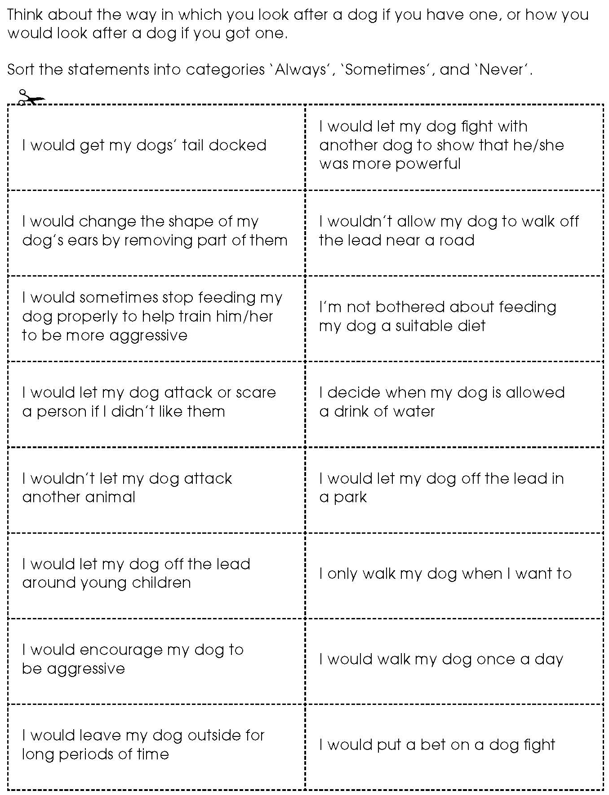

Activity sheet – My behaviour towards dogs (2)
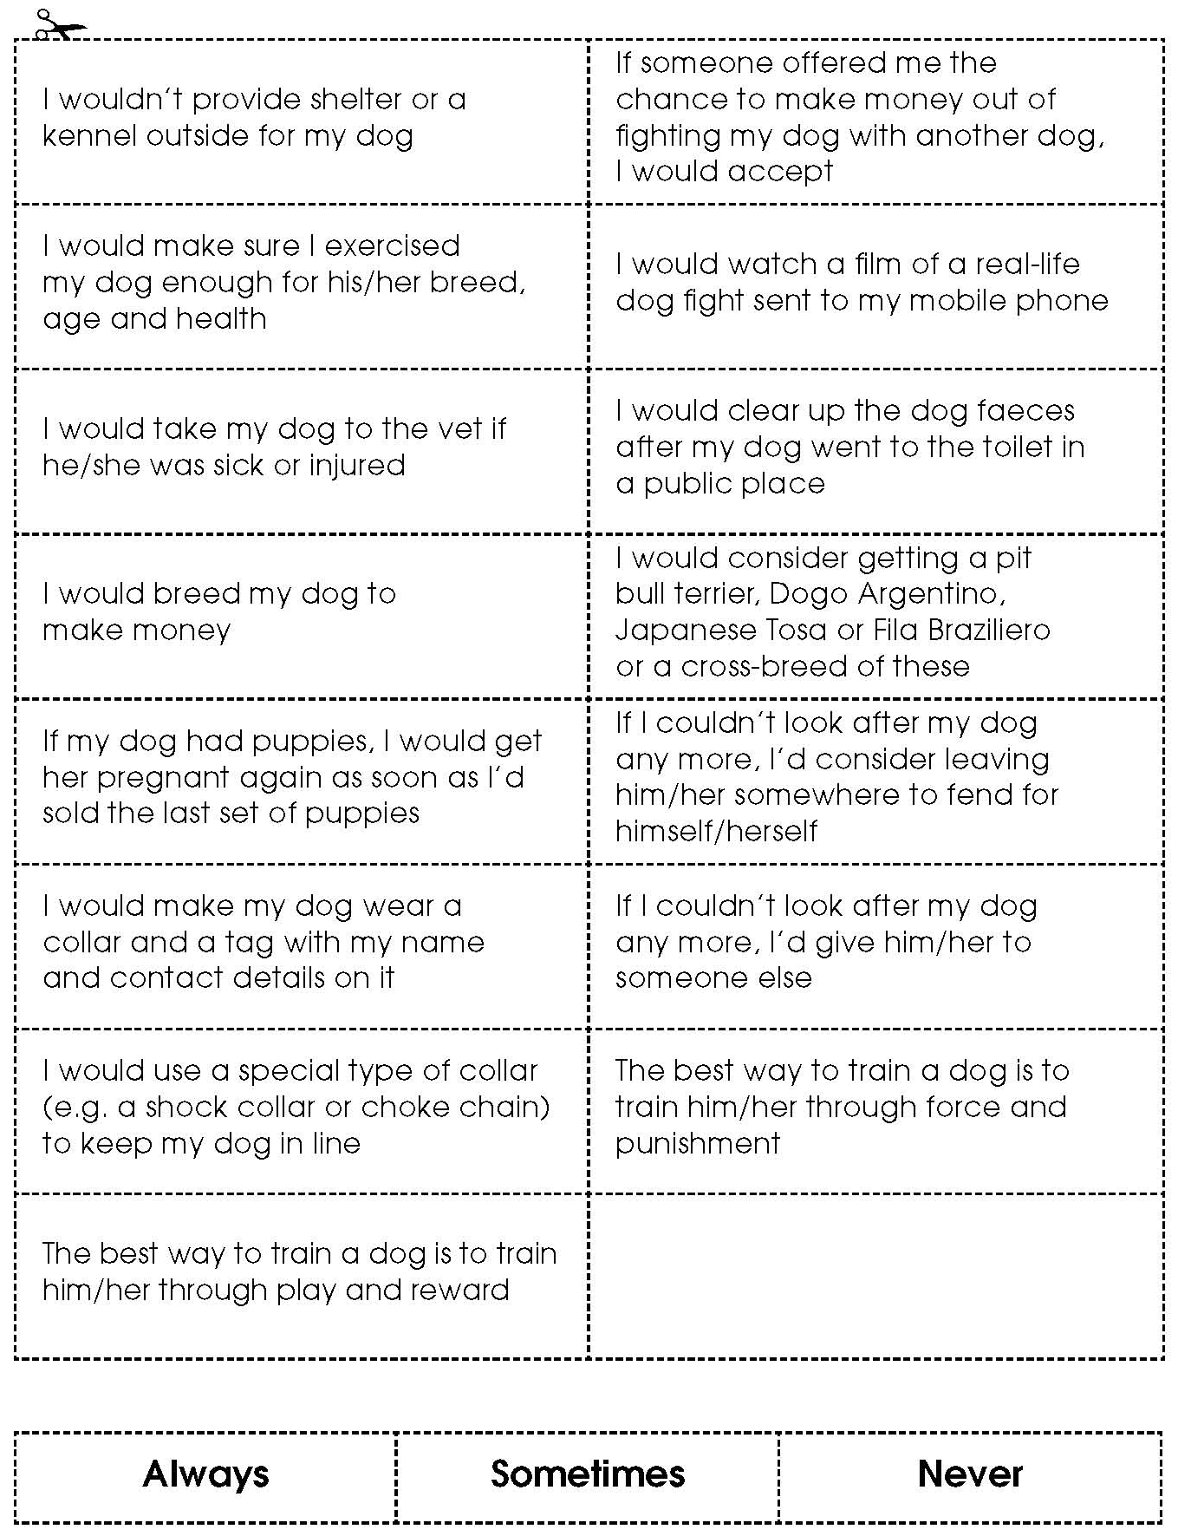

Activity sheet – What could happen to me if I break the law?

What is the issue? | Penalties and punishments for breaking the law
 | AFine | Prison sentence | Bannedfrom keeping another dog | Dog confi scated or destroyed | Pay compensation | Other | Nothing
I dock my dog’s tail or cut his/her ears for cosmetic reasons
I let my dog scare or injure another person
I don’t keep my dog on a lead next to a road
I don’t feed my dog the right food
I arrange a dogfi ght
I place a bet on a dogfi ght
I let my dogfi ght another dog
I don’t take my dog to a vet if he/she is sick
I breed my female dog more than is allowed
I don’t make my dog wear a collar and ID tag in a public place
I don’t exercise my dog enough for his/her breed, health and age
I hurt my dog by using a collar in the wrong way
I kick my dog because he/she has been naughty or does not do what he/she has been told
I train my dog by beating and punishing him/her
I don’t clear up my dog’s dog mess
I have an illegal type of dog, e.g. a pit bull terrier cross-breed
I abandon my dog because I can’t look after him/her any more
I leave my dog outside all day to get cold, wet and to suffer
I allow my dog to suffer by not looking after him/her properly or providing what he/she needs to be happy and healthy

Activity sheet – action plan for me and my dog

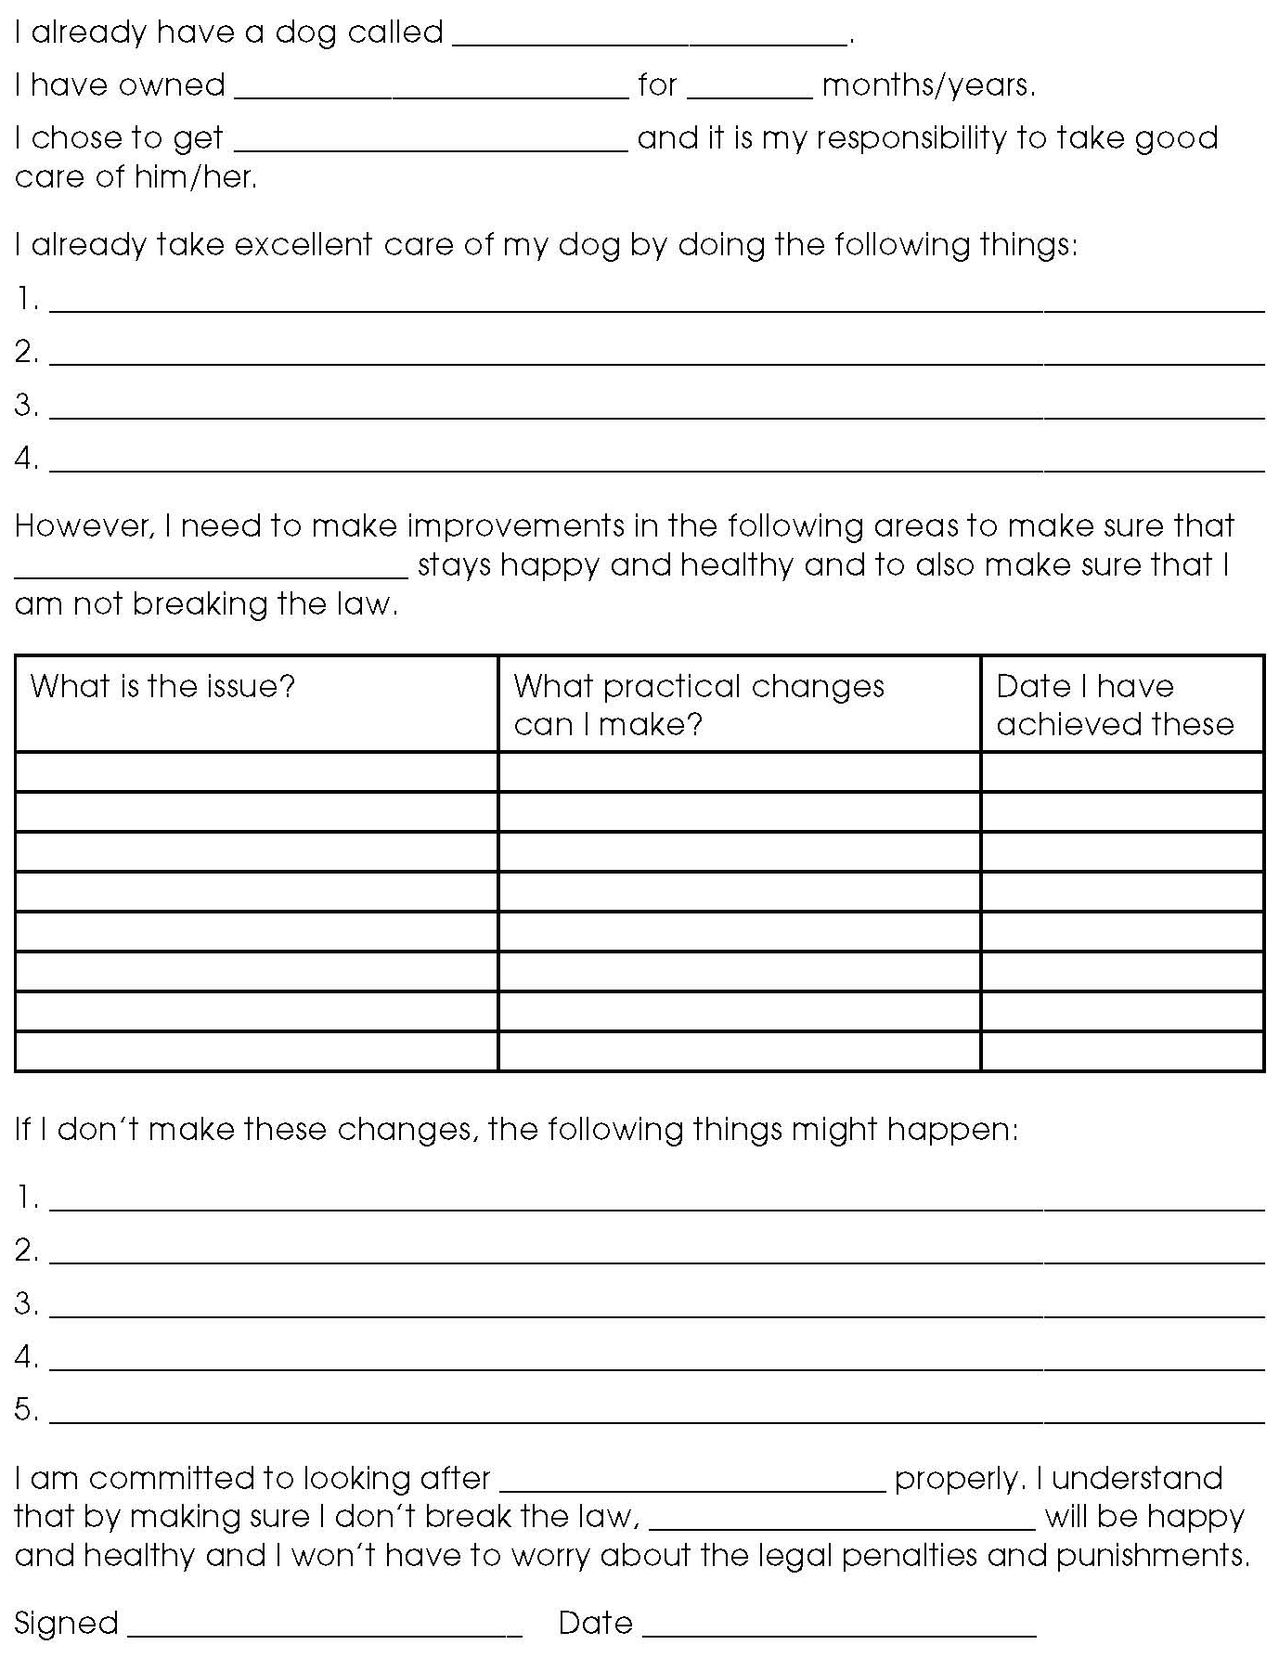

Activity sheet – Future action plan if I get a dog

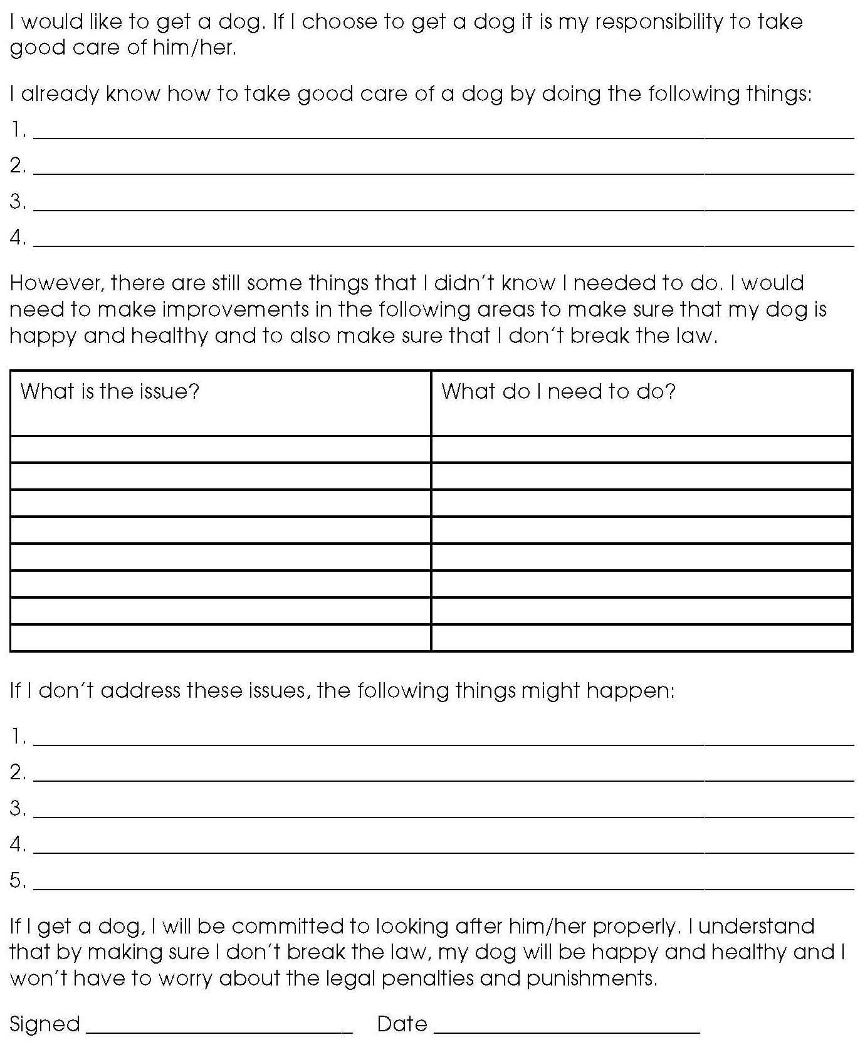
Facilitators’ notes – My behaviour towards dogs recording sheet 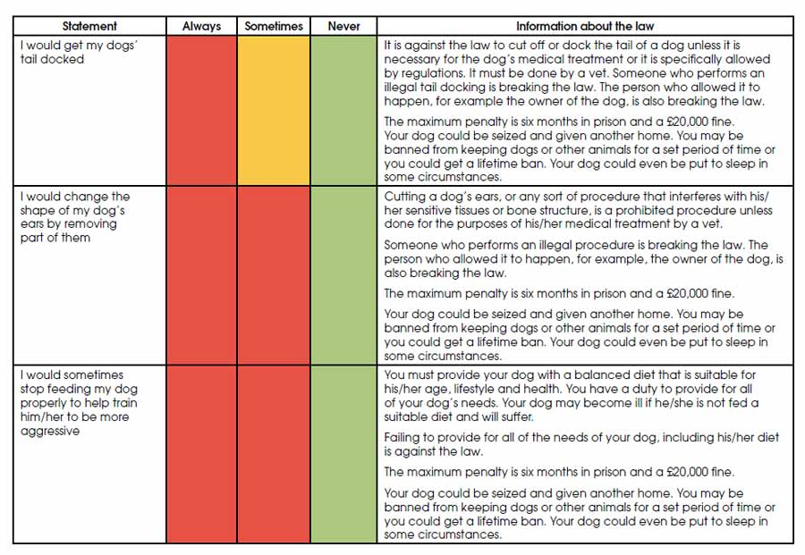
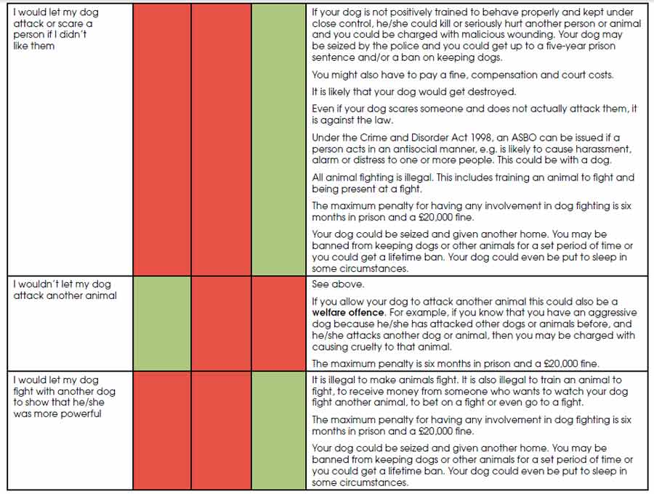

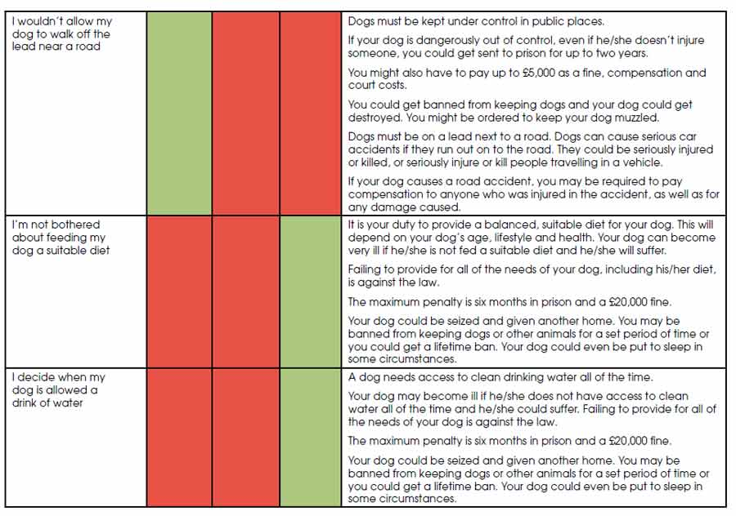
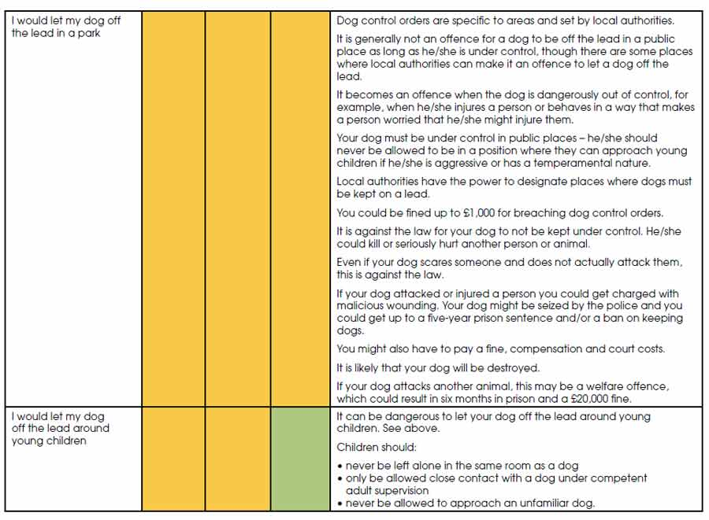
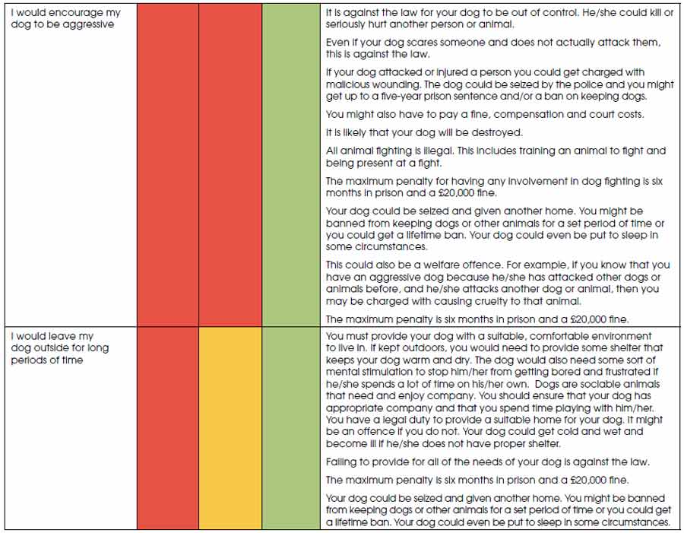
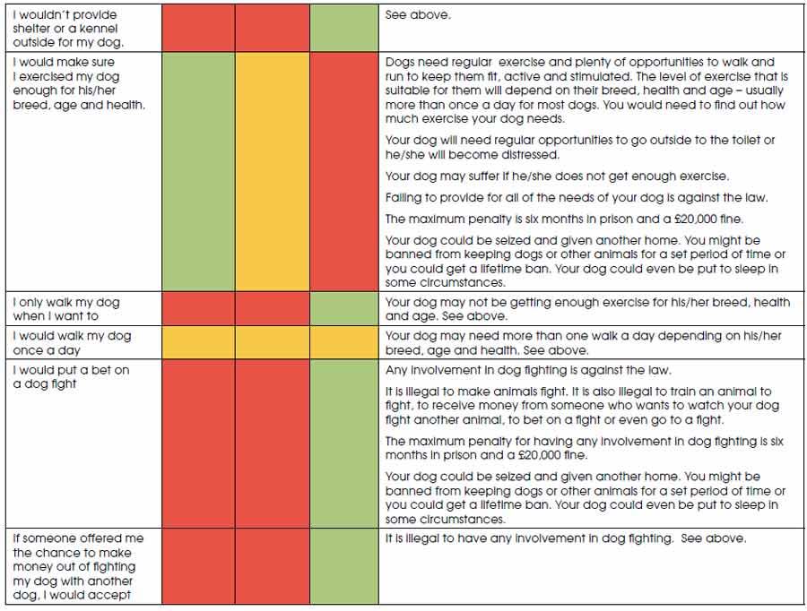
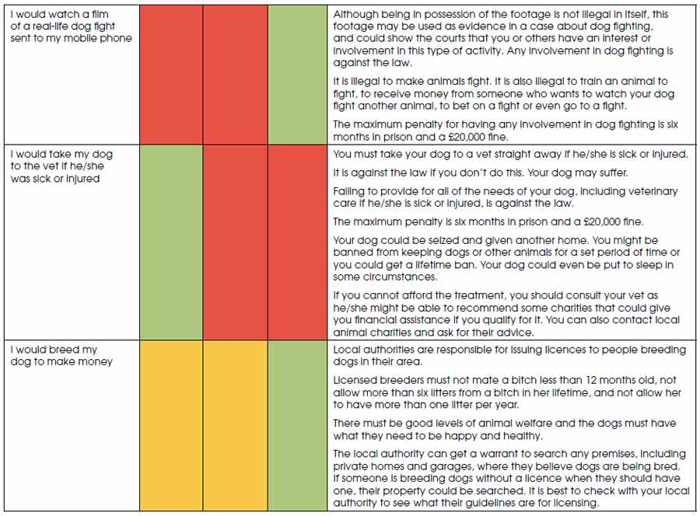

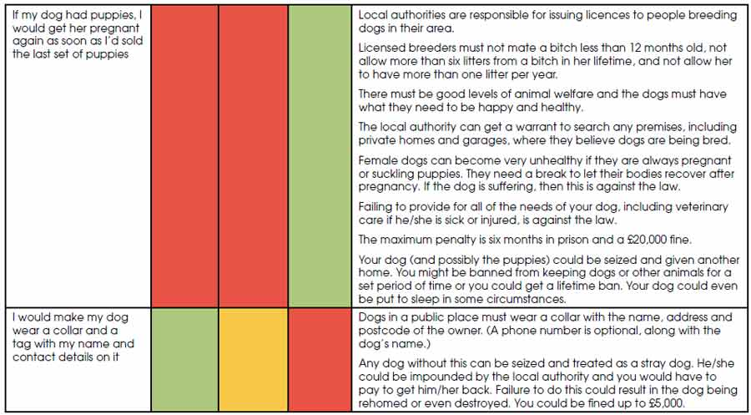

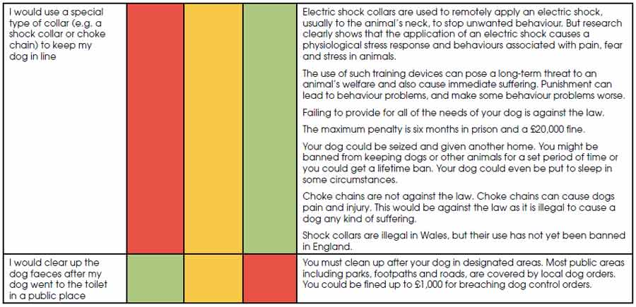

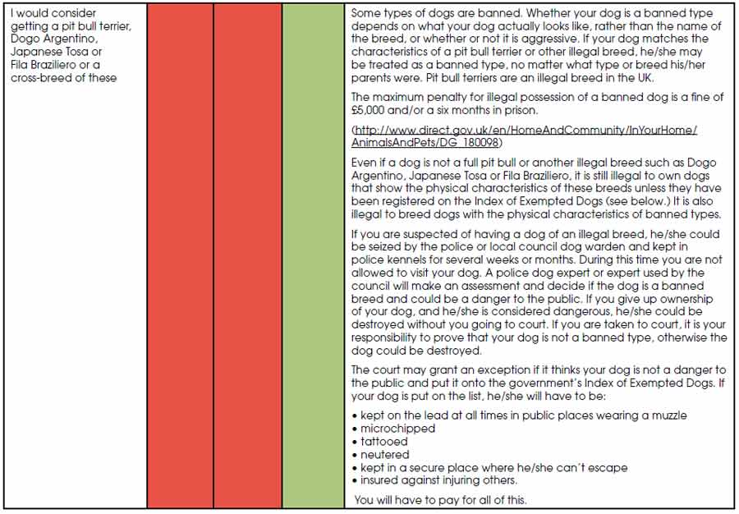
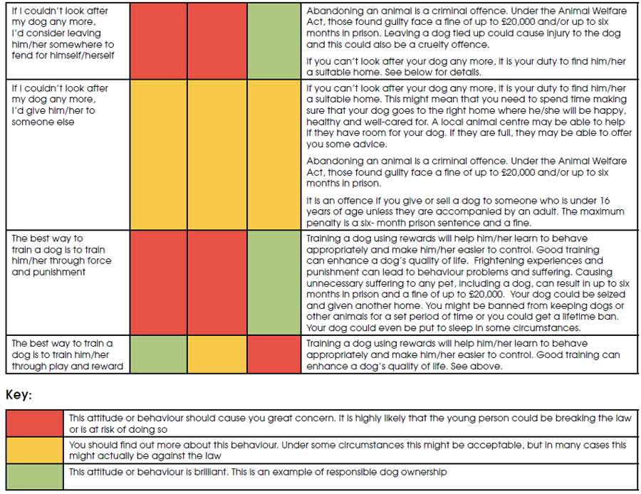
Facilitators’ notes – What could happen to me if I break the law?

What is the issue? | Penalties and punishments for breaking the law
 | AFine | Prison sentence | Bannedfrom keeping another dog | Dog confi scated or destroyed | Pay compensation | Other | Nothing
I dock my dog’s tail or cut his/her ears for cosmetic reasons |  |  |  |  |  | Pay court costs
I let my dog scare or injure another person |  |  |  |  |  | ASBO
I don’t keep my dog on a lead next to a road
I don’t feed my dog the right food
I arrange a dogfi ght
I place a bet on a dogfi ght
I let my dogfi ght another dog
I don’t take my dog to a vet if he/she is sick
I breed my female dog more than is allowed
I don’t make my dog wear a collar and ID tag in a public place
I don’t exercise my dog enough for his/her breed, health and age
I hurt my dog by using a collar in the wrong way
I kick my dog because he/she has been naughty or does not do what he/she has been told
I train my dog by beating and punishing him/her
I don’t clear up my dog’s dog mess |  |  |  |  |  | Pay court costs
I have an illegal type of dog, e.g. a pit bull terrier cross-breed |  |  |  |  |  | Register the dog on the Index of Exempted Dogs
I abandon my dog because I can’t look after him/her any more
I leave my dog outside all day to get cold, wet and to suffer
I allow my dog to suffer by not looking after him/her properly or providing what he/she needs to be happy and healthy

Facilitators’ notes – Animals’ basic needs – dogs (1)

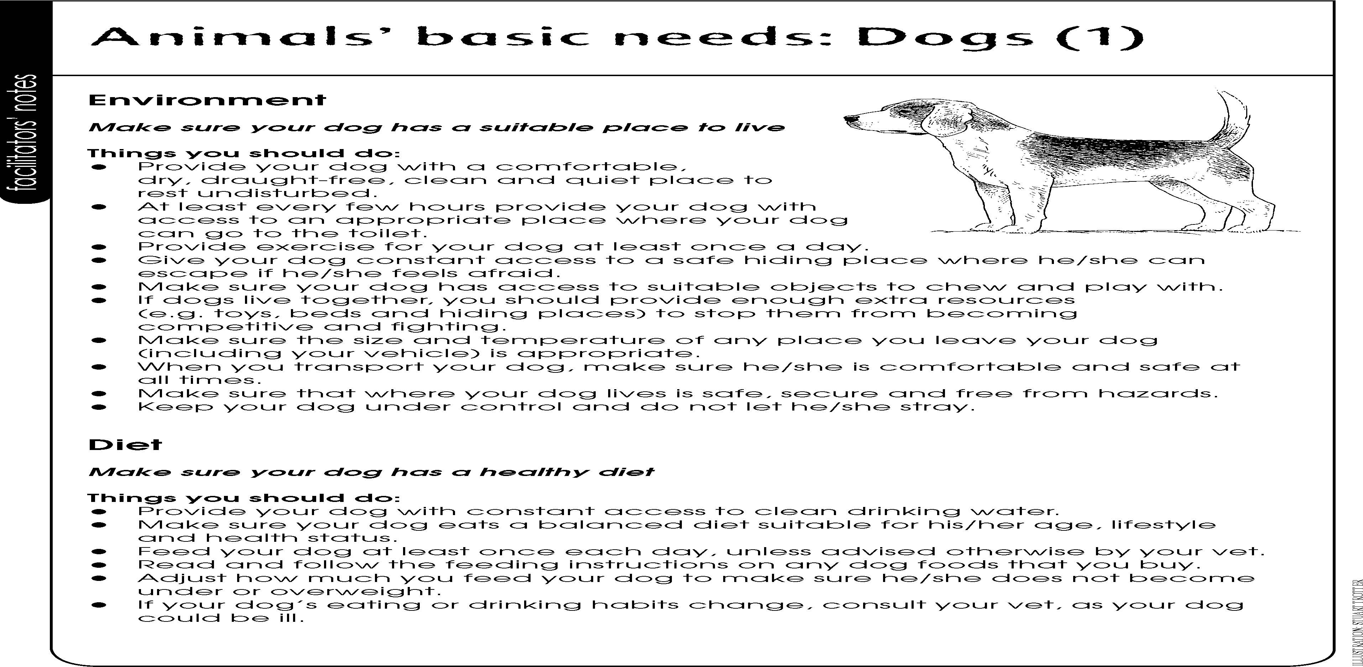

Facilitators’ notes – Animals’ basic needs – dogs (2)

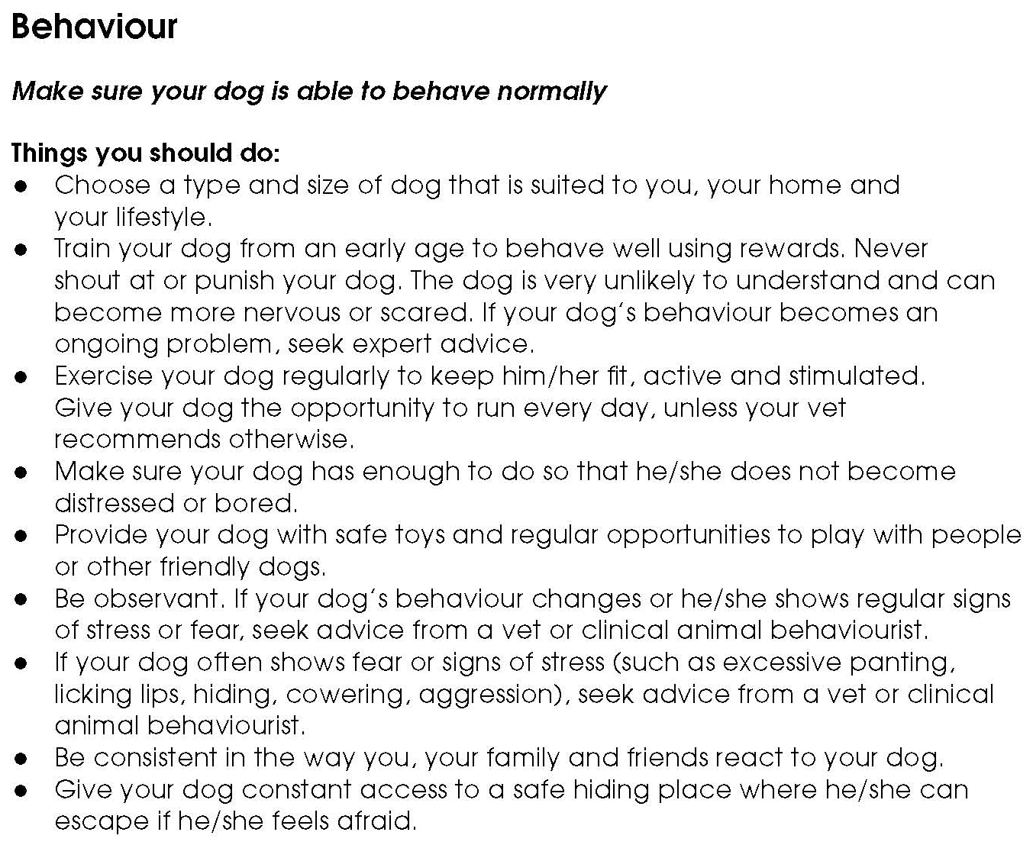

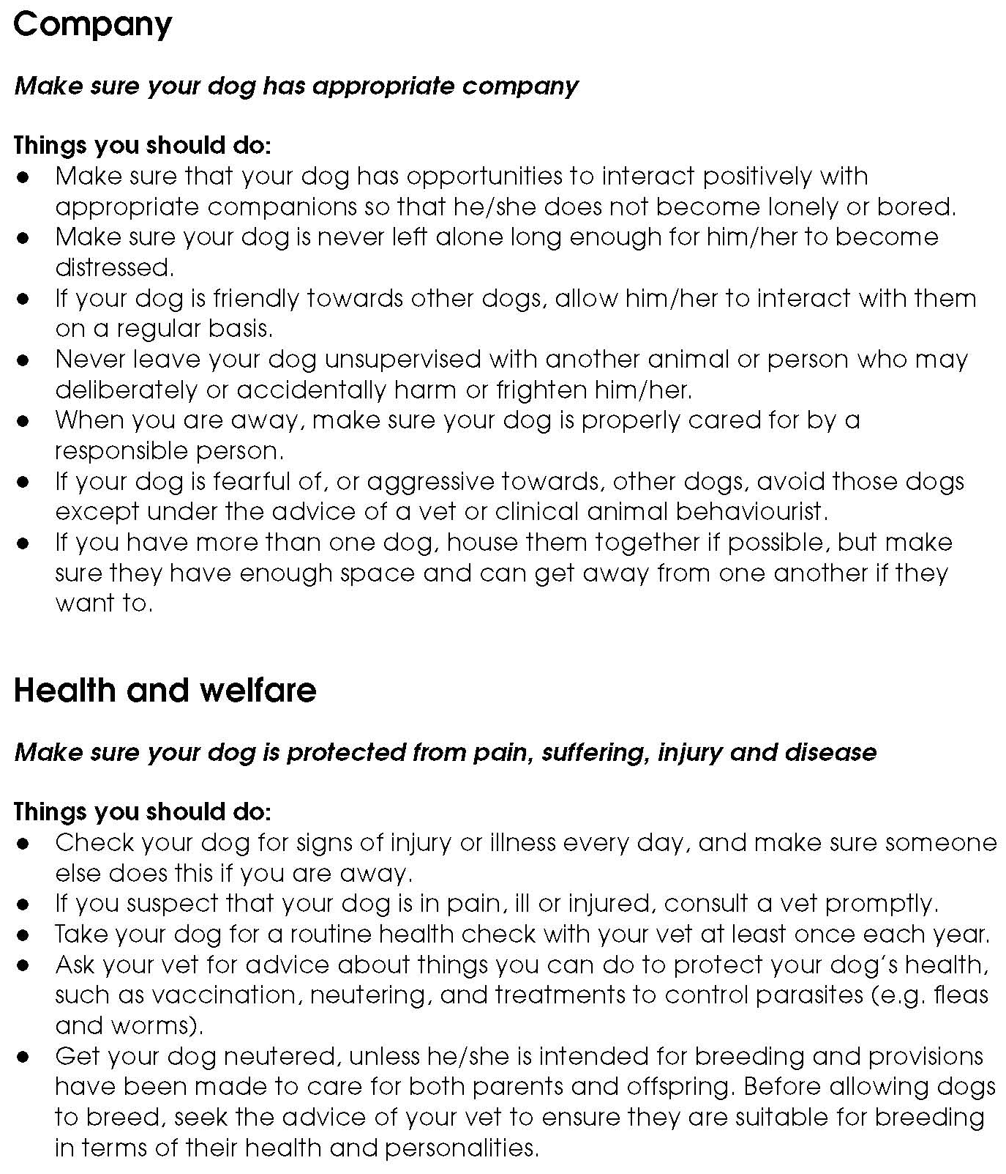
Facilitators’ notes – Animals’ basic needs – dogs (3)

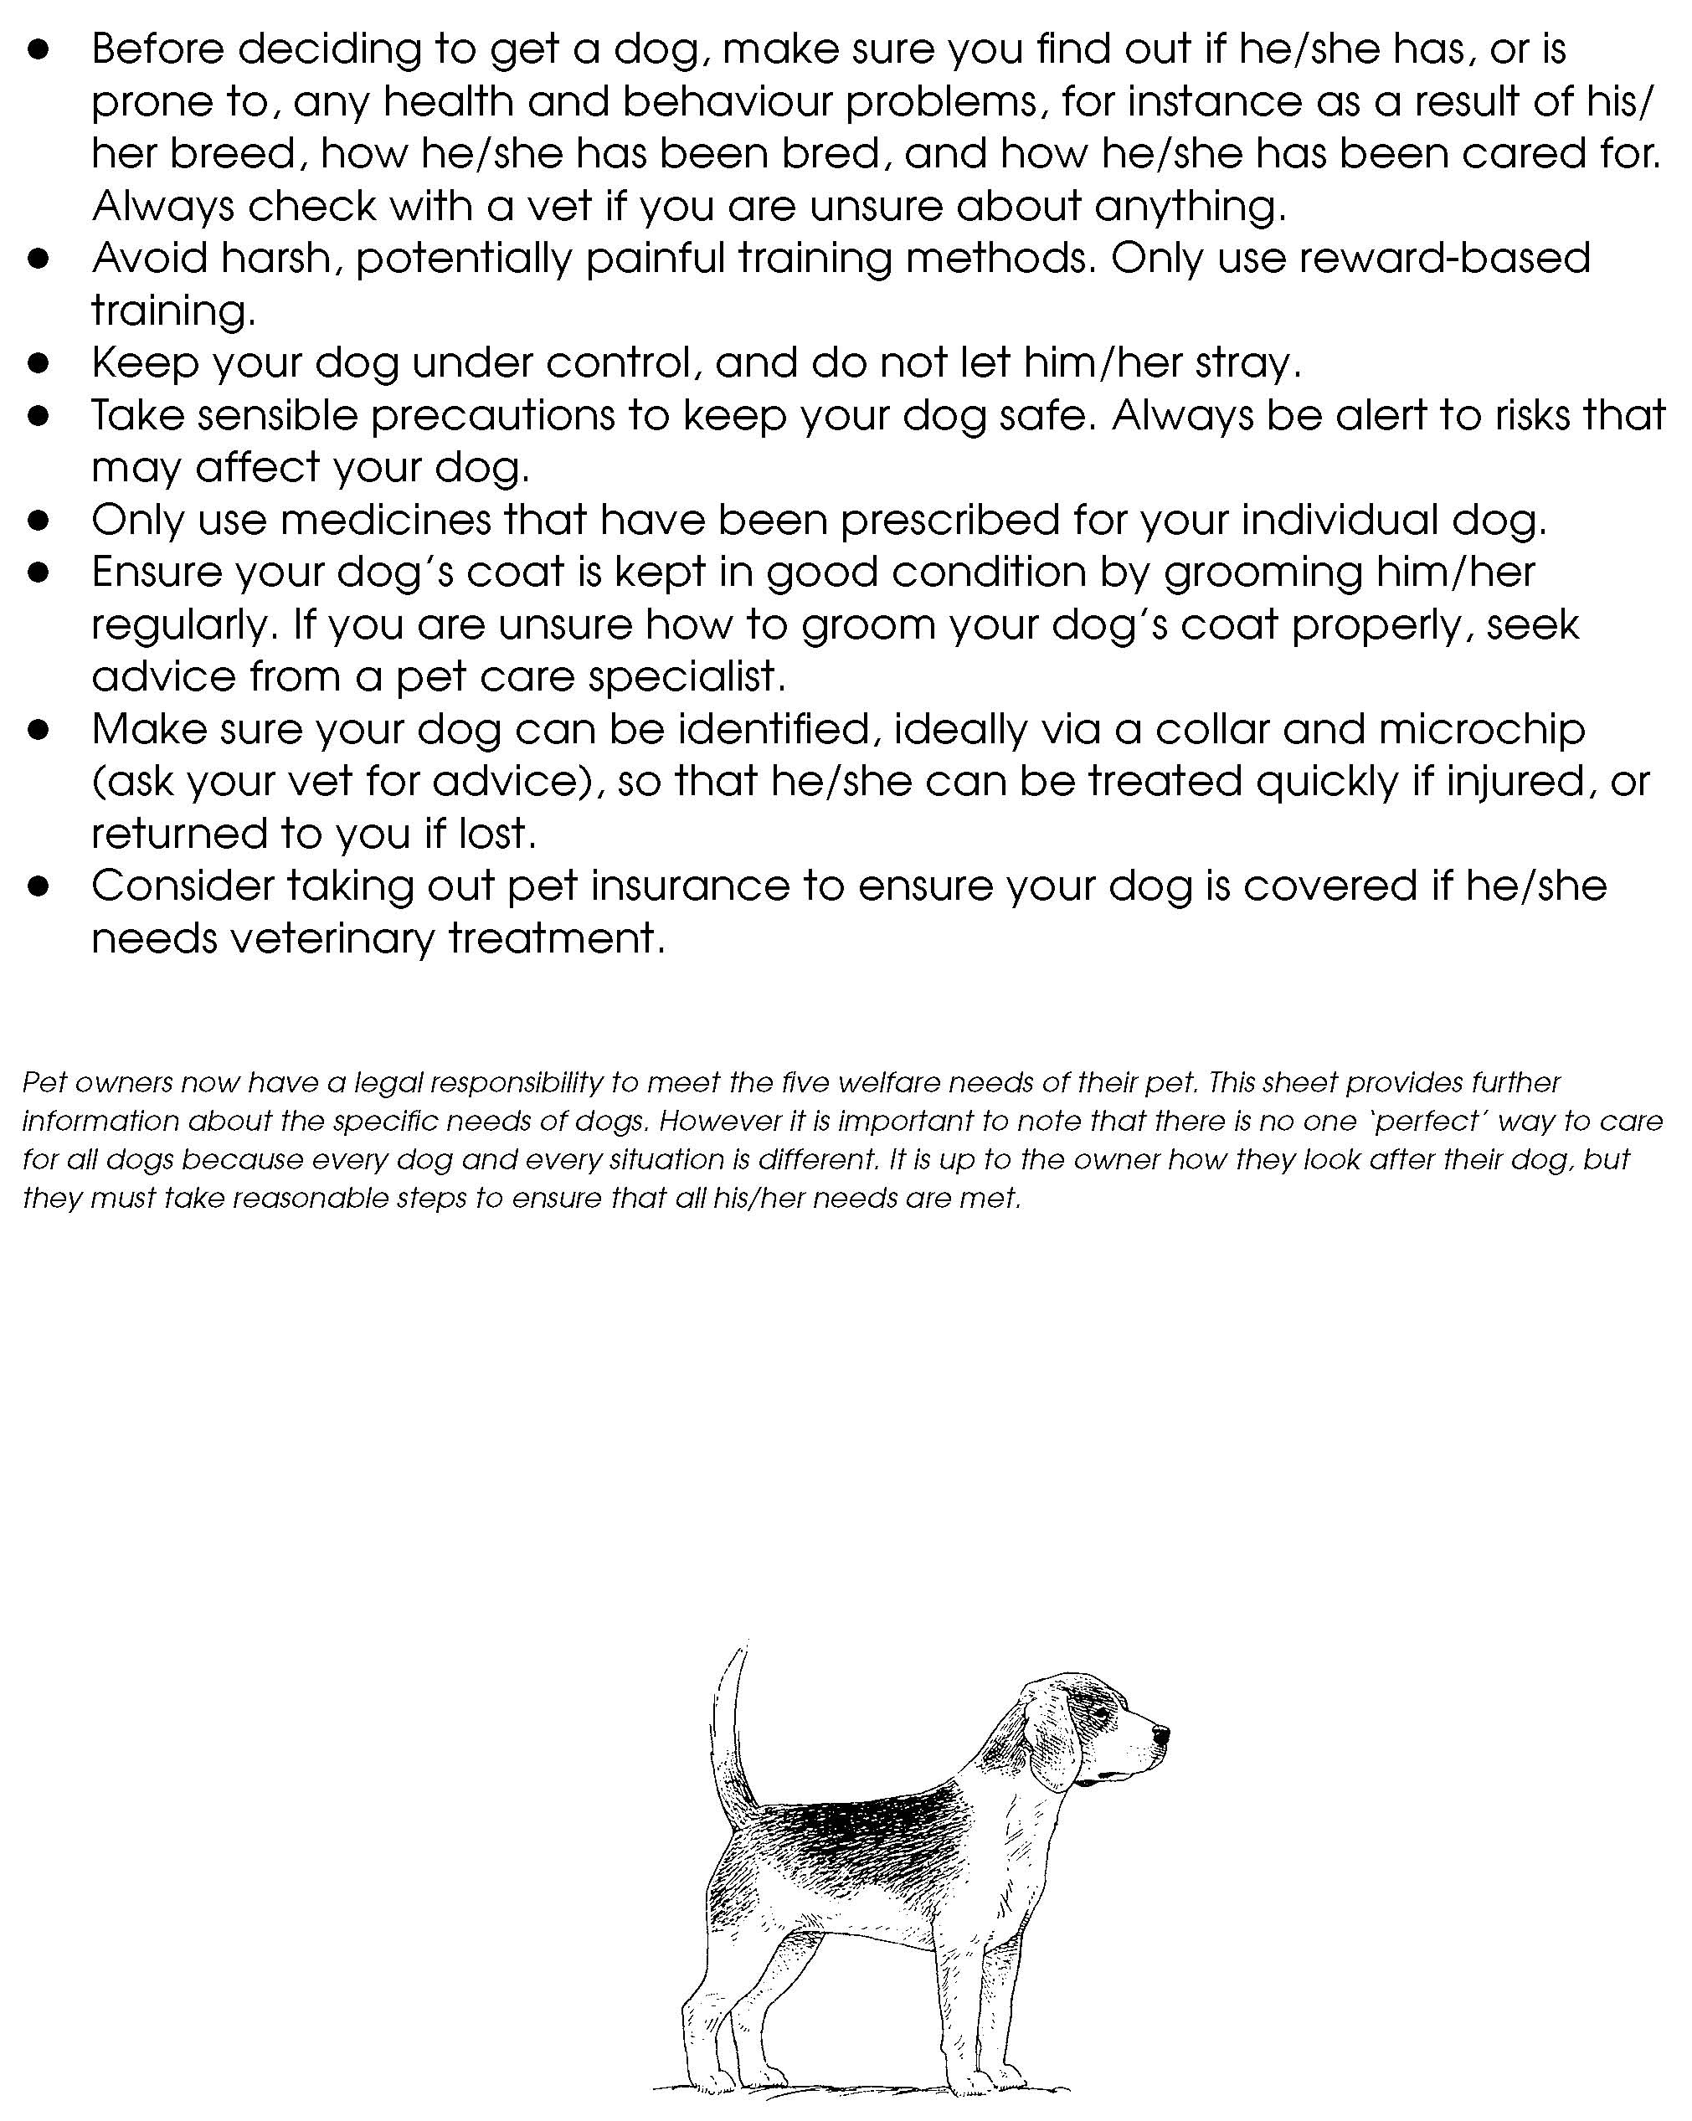
Facilitators’ notes – Animals’ basic needs – dogs (4)

Fact sheet – The five freedoms

